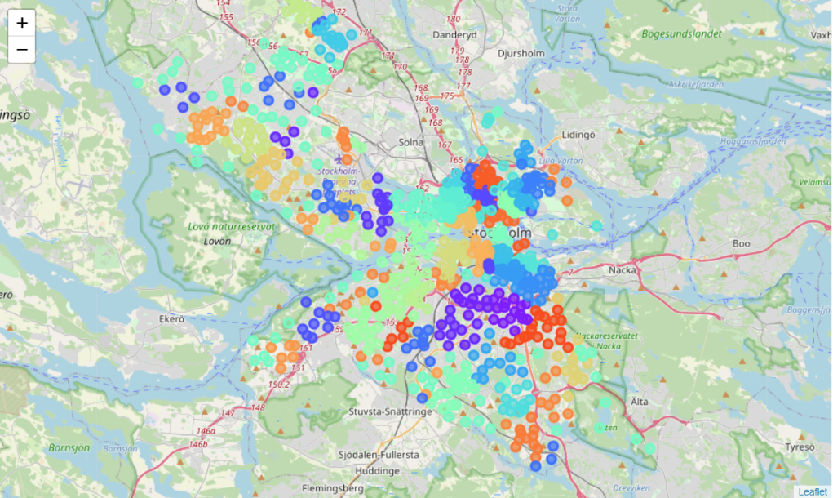

Coursera Data Science Capstone Project

2021

Table of Contents

Introduction and Background 1

Definition of Problem 1

Potential Stakeholders of the Report 1

Methodology 2

Data Collection and processing 2

Data Sources 2

Data Processing 4

Exploratory Data Analysis 5

Machine Learning 8

Results and Analysis 8

Discussion 12

Conclusion 13

# Introduction and Background

During the spring of 2021, I finished my engineering studies and got a job opportunity in Stockholm, Sweden. During my studies, I have moved a couple of times, and I have enjoyed some areas more than others. My current living area is by far my favourite. For this project, I was wondering if data science could help inform me about similar areas in Stockholm.

I have found that whether I have liked living in a certain area or not often comes down to the things that are close to it, for example, if there is a supermarket, bus stop or pizza restaurant close by. Therefore, the idea of using foursquare data to identify suitable living areas emerged. Since I really like living at my current address, I would optimally like to move into a similar area in Stockholm with regards to the nearby venues.

## Definition of Problem

Finding a new suitable location to live can be a daunting decision. The information available to decide between areas can be scarce. One aspect that is sometimes overlooked when looking for a new place to live is to consider what services and venues are in proximity. Therefore, this study looks at the category of venues that are within walking distance from different areas. The aim is to compare potential living areas with a current, or preferred living area, to identify what areas are similar in terms of nearby venues. This information may be very useful and enable anyone looking to move to make a better, more data-driven decision.

## Potential Stakeholders of the Report

As previously mentioned, the main target for this study are people looking to relocate. While nearby venues are not the only factor to consider when moving between cities, I would argue it is an important one. Therefore, this study can provide important information to anyone looking to relocate, and it could even help to identify suitable living areas. This study compares the author’s current living area with living areas in Stockholm, but the study can easily be recreated and modified to suit other people’s needs.

The information obtained through this study can also be of use to other stakeholders. For instance, realtors may use the information to match buyers with available houses in different areas. They could provide better recommendations to their potential clients using data. City planners could also use the information to get a better understanding about what makes certain areas attractive to a population. This could, for example, prove useful for cities with aging populations that need to for example attract a younger people.

# Methodology

## Data Collection and processing

In Sweden, every address has a postal code. The postal code is unique to a neighbourhood and mainly used for mailmen and other logistics actors to deliver mail and packages. The postal code is also accompanied by a city name. Large cities and municipalities will have many postal codes and city names, in that case the city name can refer to a part of a city. Stockholm municipality has 27 such cities, with a total of 1605 postal code, according to a website called “postnummerservice.se”. However, these also include administrative postal codes that corresponds to a company or agency rather than a geographical area. Another website, “worldpostalcodes.org”, states that there are 785 geographical postal codes in Stockholm. The area of a postal code is in general rather small. This enables a more detailed analysis of potential living areas in Stockholm. For examples, my current postal code, 417 57 Göteborg, only encompasses an area of 164 square metres, housing about 700 people. A map of this postal code can be seen in Figure 1, illustrating the area that each postal code represent.

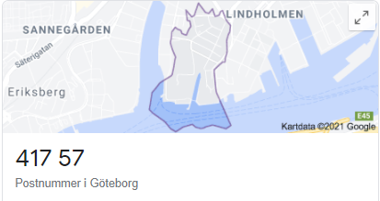

Figure 1 A map showing postal code 417 57 in Gothenburg, Sweden.

The data needed for this project are the relevant postal codes, their coordinates and their nearby venues from the foursquare data base. The sources of data will be presented in the following section, along with some examples of what features that the data contain.

### Data Sources

In this project, the necessary information was gathered from four data sources. Two different methods were also used of collecting the data. Scraping was used in one to collect the data from two of the sources, while the other two sources were accessed through API calls. The data sources are presented below.

#### Worldpostalcodes.org

The webpage worldpostalcodes.org host many postal codes within Sweden and throughout the world. Originally, another webpage was planned to be used, but since it was protected from scraping, I had to resort to worldpostalcodes.org. While the coordinates were not visible on the webpage, they were embedded in the HTML code and could therefore be scraped as well as the postal code and the city. The package Beautiful Soup was used to scrape the webpage. It can be accessed on the following link: <https://www.worldpostalcodes.org/l1/en/se/sweden/map/r2/map-of-postalcodes-in-goteborgs-stad>

#### Postnummerservice (Postal Code Service)

The website postnummerservice, or Postal Code Service in English, was scraped using the Beautiful Soup package. Postnummerservice is a data base that houses postal codes, addresses etc. From my understanding, it is the most official of the data sources and it is recommended on the public statistics agency’s webpage. Sadly, they did not have a free to use API, which is why the web page was scraped for the cities within Stockholm municipality. Since very little information could be accessed for free on this web-page, only the names of the 27 cities in Stockholm municipality were acquired. Some examples of these city names are Bromma and Årsta. These city names were then used to acquire postal codes from the following data base, PAP/Lite. The scraped webpage can be accessed from the following link. <https://www.postnummerservice.se/information/svenska-postnummer-och-postorter/stockholm/stockholm-kommun/>

#### PAP/Lite

I found a data base with a free personal API that contained the information needed. The API could be called using either a postal code or a city. For the free version, a very limited amount of 500 calls could be made every day. Since Stockholm municipality contains 1605 postal codes but only 27 cities, the latter version of the API call was used. The response contained up to 100 postal codes, which meant that for some cities, not all postal codes were returned. This was a limitation in the API that resulted in only 718 postal codes were collected. Four cities were affected by this: Two cities were affected by this, Stockholm and Bromma. Most of the missing postal codes were located in central Stockholm.

The response from the database came in JSON format, and included the following features: Postal code, city, latitude, longitude, county code, county, state code, state, notes, and date updated. However, only the following features were kept: Postal code, city, latitude, and longitude. Indormation about the API can be found on: <https://papilite.se/>

#### Foursquare

The foursquare API was used to identify nearby venues. The coordinates for each postal code were used as inputs to the API call. The limit was set to 20 venues and the radius was set to 1000 meters, as this was deemed to be convenient walking distance. The response from foursquare contains a large number of features, but the following ones were kept: name of venue, venue latitude, venue longitude, and category of venue. Since calling foursquare with all postal codes took a long time, some lines of codes were also written so that the API was only called if a response had not been cached. This reduced the runtime significantly. The same was also done when calling the PAP/Lite API to reduce runtime further.

### Data Processing

The data collection process consisted of two stages. First, the data set with the postal codes, city names and coordinates was acquired. Second, it was used to call the foursquare API to get venue data. After collecting the data for postal codes, it was plotted using Folium to investigate the data set, as seem in Figure 2. Preliminary analysis showed that the data from the PAP/Lite API contained some postal codes that should not be included in Stockholm municipality and there were many postal codes missing from central Stockholm due to limitations in the API. The city names were spread as expected between the different cities, which refers to parts of Stockholm as described earlier. 718 postal codes were returned from the API within Stockholm municipality.

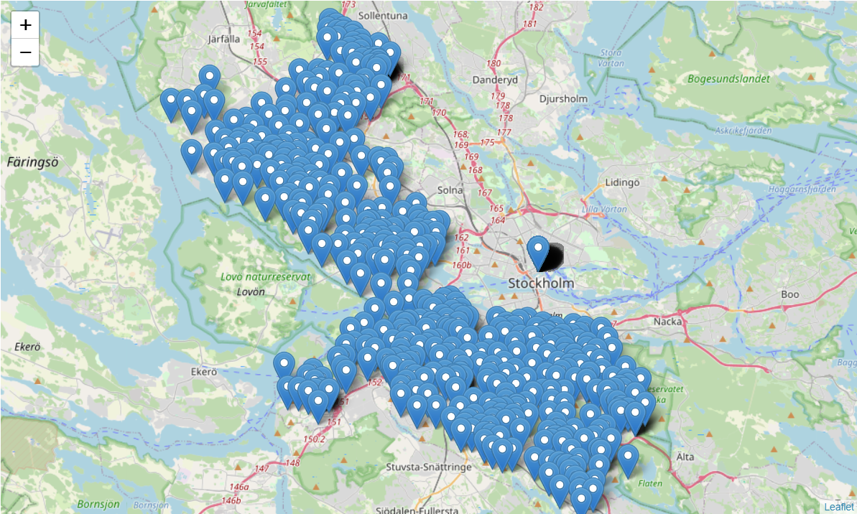

Figure 2 The data set from the PAP/Lite API

The webpage worldpostalcodes.org was scraped and the resulting data set was also examined. It contained 785 postal codes in Stockholm municipality. The same webpage was also scraped for information about my current living area in Gothenburg, making the total 786 postal codes. When plotting the data, as seen in Figure 3, the postal codes followed the borders of the municipality closer that the data set from the API, and there were no empty spots for example in central Stockholm. However, the distribution of cities was not according to expectations. There were 113 different cities returned, with the majority being simply Stockholm.

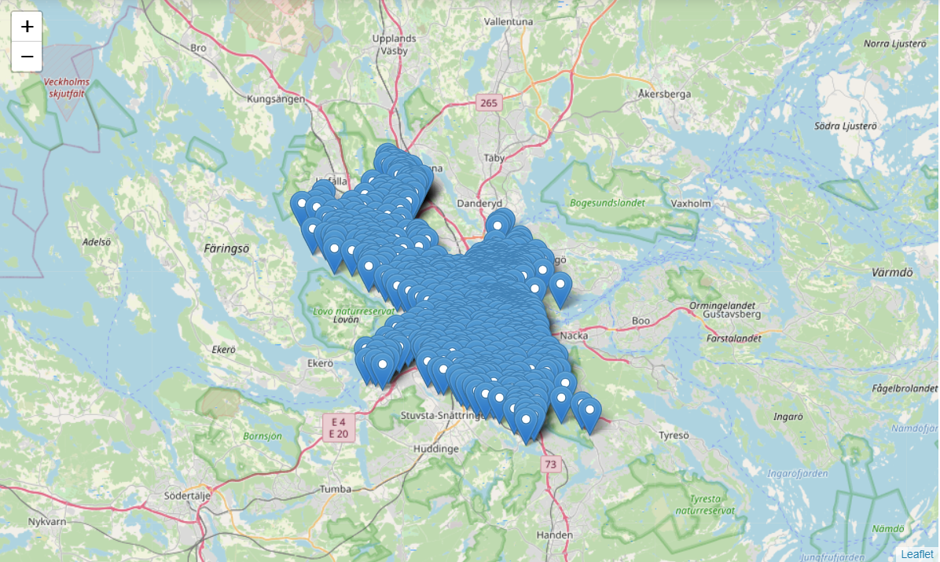

Figure 3 The data from worldpostalcodes.org plotted using Folium

Therefore, I decided to combine the two data sources. The API resulted in better city names for the postal codes while the scraped webpage gave better postal codes. If the postal code occurred in the results from both these sources, the postal code and coordinated from the webpage was used, but with the city from the API. This way, the distribution of postal codes among the different cities was closer than expected. There were still some city names that referred to only one or two postal codes, but this could not be avoided since they were not present in the result from the API. The overall quality of the data set was however deemed to increase by combining the sources.

The result from the first part of the data collection was a dataframe containing the postal code, the city, latitudes, and longitudes. This was then used to call the foursquare API. The results from that database was the compiled and dummies were created. This was done to enable clustering using a K-means algorithm. In order to get a better overview of the different venues, another dataframe was created. The category of the returned venues are displayed, with the most common category being displayed first.

## Exploratory Data Analysis

The data collection and processing mainly resulted in two dataframes. The first dataframe, which can be seen in Figure 4, contains 786 rows and 260 columns. The first four columns contain the postal code, city name, latitude, and longitude. The remaining columns contains dummies representing all the categories of venues that were returned by foursquare. This data frame will later be used to train the clustering algorithm.

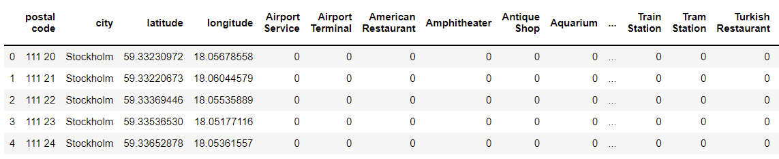

Figure 4 Dataframe containing dummies for the foursquare results

The second dataframe can be seen in Figure 5 and it was created to get a better overview of the venues for each postal code. It contains all the 786 rows corresponding to the individual postal codes but only 24 colums. The first four columns are postal codes, city, latitude, and longitude, similar to the other dataframe. The remaining 20 columns are the name of the venue categories, starting with the most common category. If a postal code does not have 20 venues with different categories, or if the foursquare response contained less than 20 venues for a postal code, it is represented by NaN in the dataframe. 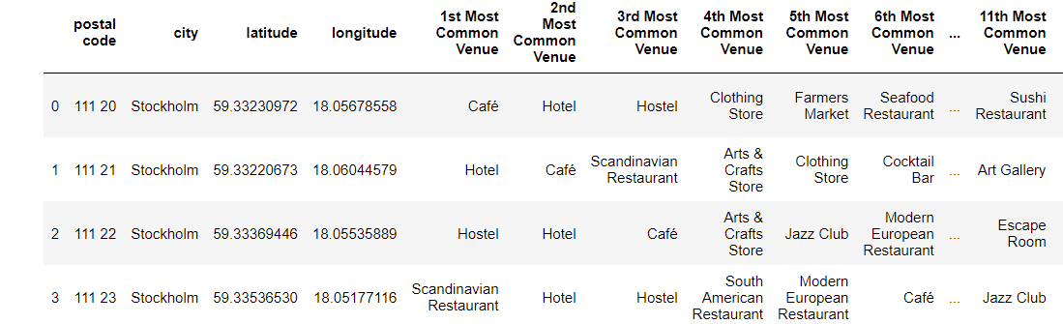

Figure 5 Dataframe containing the venue category in order

My current postal address in Gothenburg returned 20 venues. The most common venue category was café, and there were three cafés within 1000 meters from the postal code. The second most common category was vegetarian/vegan restaurant, with two venues. The remaining venue categories each had one venue and included a hotel, a marina and history museum. The distribution among all the categories can be seen in the pie chart in Figure X below.

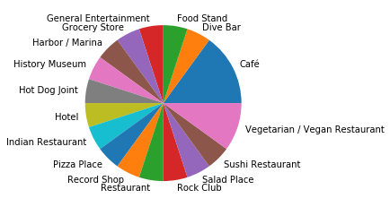

Figure 6 The venues returned for my current postal code

.

The most common venue category for the entire data set was Pizza Place. More than half of the postal codes, or 499 codes, had one or more café returned by foursquare. The second most common venue category was pizza place, which 441 postal codes had within the radius. Scandinavian Restaurants were close to 392 postal codes and 385 postal codes had bakery within 1000 metres. The fifth most common venue category was grocery store, being in the proximity to 308 postal codes. The ten most common venues can be shown in figure 7.

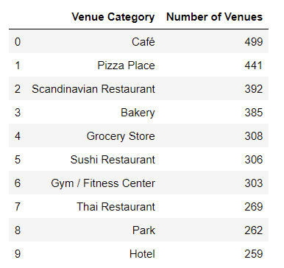

Figure 7 The most common venue categories. The Number of venues is the number of postal codes with at least one such venue nearby.

To understand the different postal codes better, I investigated how similar they were to my current postal code. I looked into this by looping through all the postal codes, comparing each one to my current postal code and counting the number of venue categories they have in common. The most similar postal codes had seven venue categories in common with my current living area. There were four such postal codes, two located in central Stockholm and two located in Bromma, which is in the western part of Stockholm. The average number of venue categories in common were also investigate, as shown in figure 8. Two cities had 5 venues in common on average, but these cities only contained a small number of postal codes. Two larger cities had 4.8 venues in common with my current postal code on average. These were Enskededalen and Årsta, both located south of central Stockholm. I would therefore suspect that postal codes from these cities can end up in the same cluster as my current postal code.

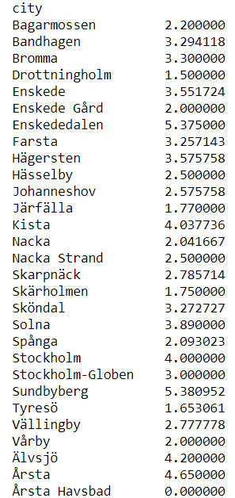

Figure 8 The average number of venues in common with my current postal code

## Machine Learning

In order to identify areas similar to my current postal code, machine learning algorithms can be used. There are several suitable algorithms used for clustering or classification. The difference between clustering and classification is mainly that classification algorithms are provided with pre-defined clusters while clustering algorithms create new clusters. For this project, a clustering algorithm called K-Means Clustering (KM) was selected. KM is an unsupervised machine learning algorithm, meaning it does not require inputs from a user but learns from patterns in the data. The number of clusters are specified and provided by a user, but the algorithm independently allocates the data points to the clusters iteratively until it has found an optimal solution. This is achieved when data points within clusters are as similar as possible, while also being as different as possible from data points in other clusters. The algorithm is initiated with a number of clusters, which is a user input.

In order to determine the optimal number of clusters, the silhouette score is used. The silhouette score is a metric between -1 and 1, and a higher score indicates that data in the same cluster are similar while being different from other clusters at the same time. The KM clustering algorithm was initiated with between 2 and 50 clusters. Three metrics were collected to evaluate the performance of the algorithms each time. These were the average silhouette score for all data points, the silhouette score for the current postal code, and the average silhouette score for the cluster that the current postal code belong to. The maximum average silhouette score was acquired when initiating the algorithm with 49 clusters. However, the maximum for both the individual current postal code and the average for its cluster was reached when the number of clusters were set to 44. Therefore, this number of clusters were used. The random state value for the KM algorithm was set to an integer in order to ensure consistency.

# Results and Analysis

Using 44 clusters to initiate the KM algorithm, my current postal code was assigned cluster 1. It is one of the smallest clusters, with only 12 postal codes. The largest cluster, cluster 21, contained 79 postal codes in comparison. The number of postal codes in the different clusters can be seen in figure 9.



Figure 9 The number of postal codes contained in each cluster

All postal codes were plotted using Folium, which can be seen in figure 10. The colour of the markers signifies what cluster that postal code belong to. Geographical distance is not a factor when clustering the postal codes. However, postal codes in proximity to each other will share a number of nearby venues, which is probably why the clusters tend to be located together geographically.

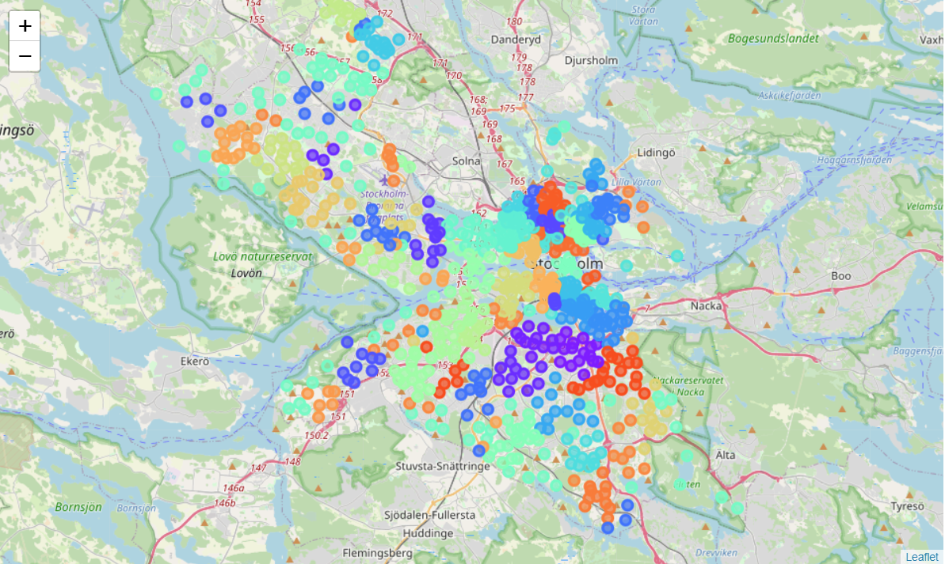

Figure 10 All postal codes plotted with the colours representing the different clusters

One cluster which is not located together geographically is cluster 21, which is also the largest cluster containing 79 postal codes, as seen in figure 11. All of the postal codes are on the other hand located in the outskirts of Stockholm, which is why they may share characteristics such as the absence of metro stations etc. The same is also true for cluster 7 and 39 which is also spread out but located in the outskirts of the city, although cluster 39 also contain some more central postal codes.

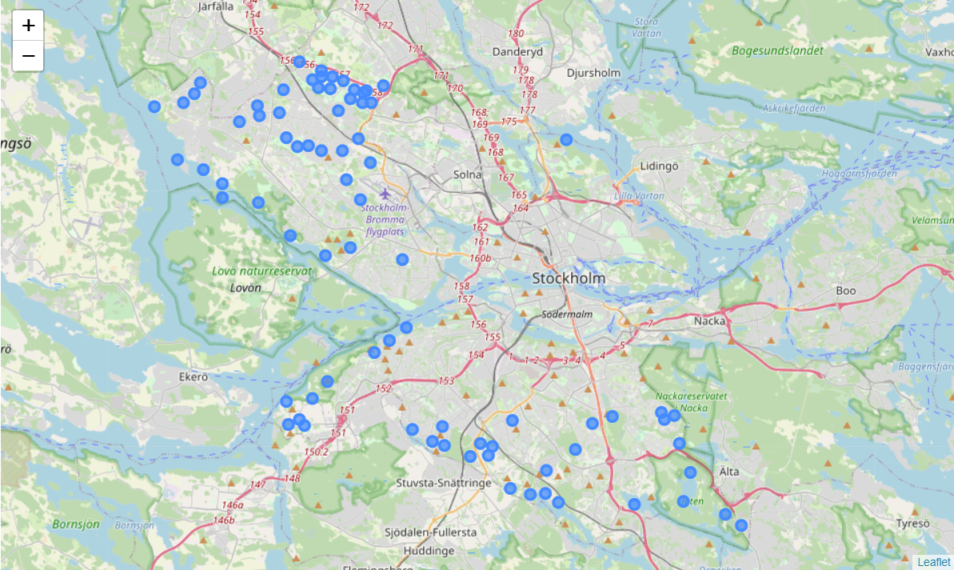

Figure 11 Cluster 21, the largest cluster.

These three clusters, 21, 7, and 39 are the largest clusters, and seem to be made up of a number of smaller clusters outside of central Stockholm. They can be compared to smaller clusters such as cluster 22, which only contains 7 postal codes in the old city in Stockholm. Since the postal codes corresponds are geographically small in densely populated areas, these postal codes are very close proximity.

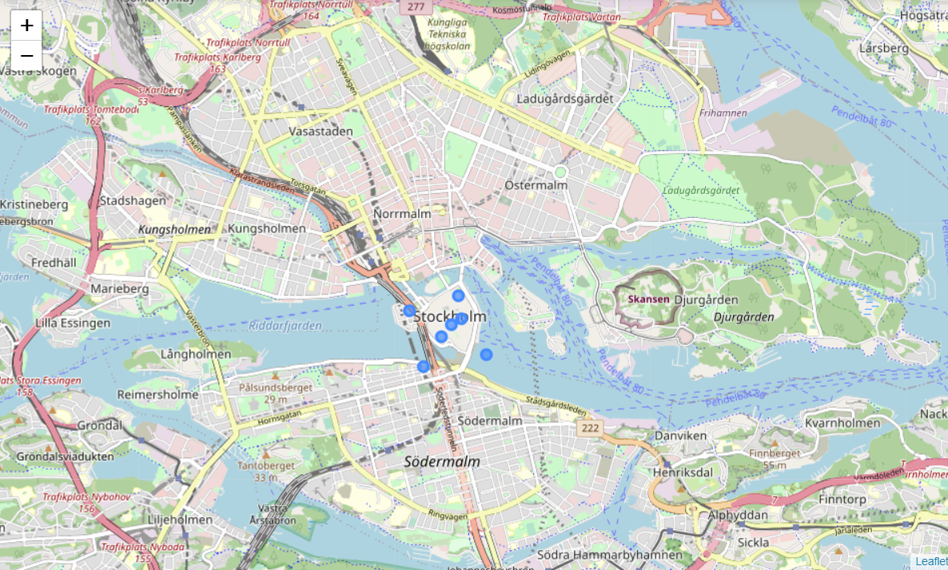

Figure 12 Cluster 22, a small cluster in Stockholm's old city

My current postal code in Gothenburg was assigned to cluster 1 as previously mentioned. The cluster contains 12 postal codes in total, as seen in figure 13. The remaining postal codes are located in the same area, Årsta, which is located south of central Stockholm. Årsta was one of the cities with the highest average number of venues in common with my current postal code, as seen in the exploratory data analysis. 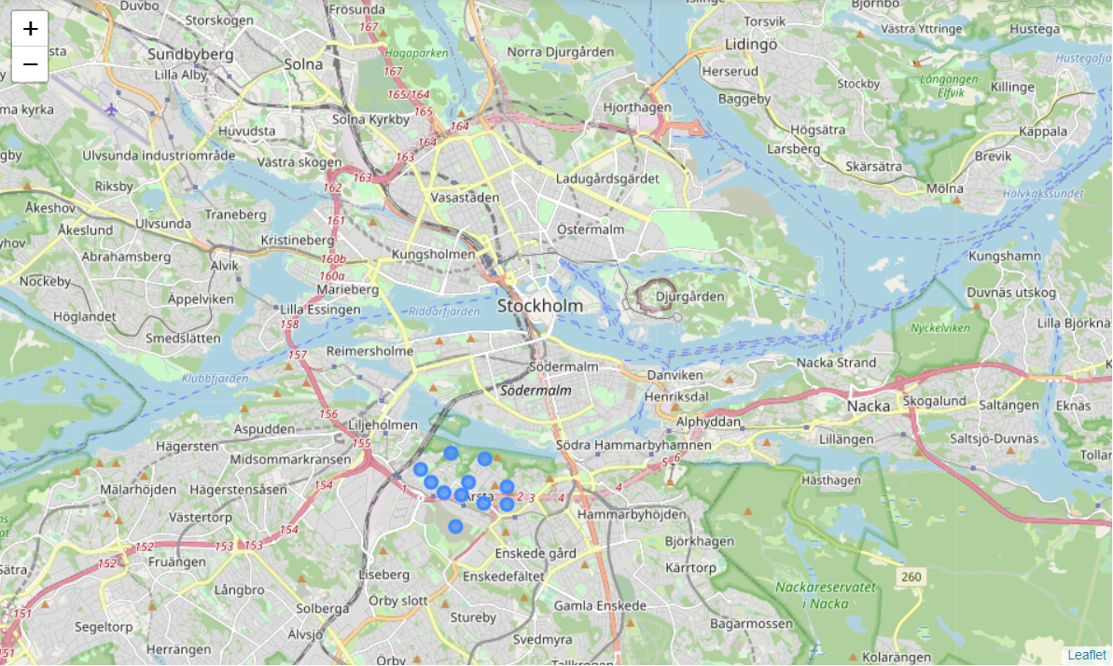

Figure 13 Cluster 1, which also include the current postal code.

Looking into the venues which were returned by Foursquare for cluster 1, some similarities are evident. The most common venues for this cluster can be seen in figure 14. The algorithm does not consider the distance between the venue and the postal code when clustering, so it is no surprise that many venue categories are the same, albeit in a different order. However, they are not extremely similar, and there are venues at my current postal code which are not present in Årsta, such as a Rock Club. Although having the highest silhouette score out of the tested values for initiating the algorithm, the score was not remarkably high. This may be because there are simply large differences in the data set. The average silhouette score for the cluster was much higher than the score for my current postal code individually. This can be observed, as the postal codes in Årsta are more like each other than my current postal code.

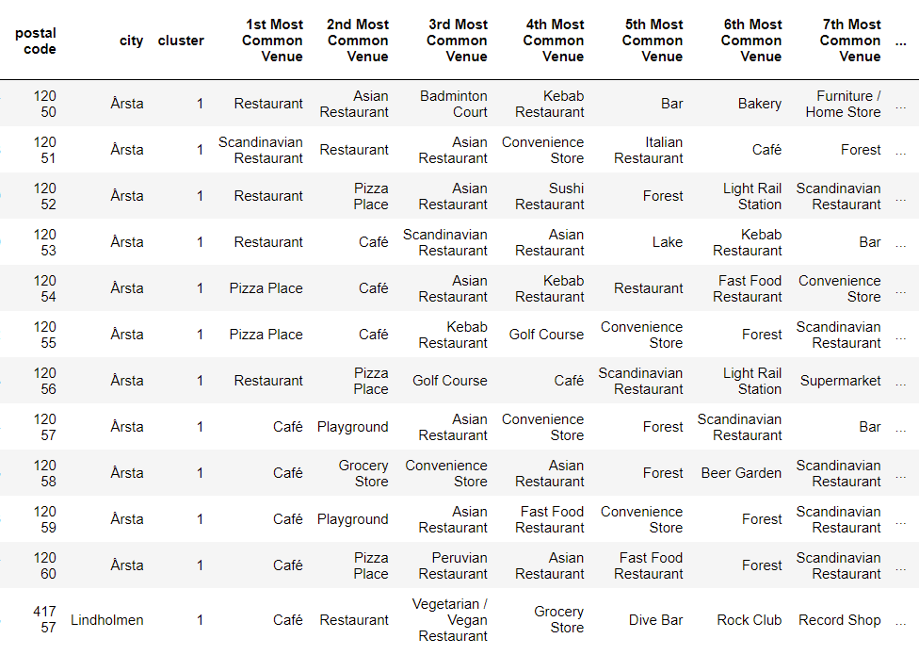

Figure 14 The most common venues for cluster 1

If we want to investigate how other clusters relate to my current postal code, we can look at the distance between the center of cluster 1 and other cluster centers. The distance metric used is the Euclidian distance from the scikit package and the cluster centers were acquired from the KM model used. Once again, it is important to remember that distance relates not to geographical distance but how similar the data subsets are. The cluster with the lowest distance to cluster 1 was cluster 39. The cluster with the largest distance, that is the least similar, was cluster 22. Both postal codes have been given as examples earlier in this section. Cluster 39 is large and spread out while cluster 22 is in the old city center of Stockholm.

# Discussion

In this project, I have tried using data science to solve a real life problem, or at least make a more informed decision. One thing that surprised me during the course of this project was how hard it was to find good, free data to use. Early on, I decided to use postal codes for the project. There were very little data available for free, and even the statistics agency referred to privately owned data bases. Using the recommended data base would cost approximately 500 USD, which I of course did not want to spend. The free data base that I used instead would prove to have fairly unreliable information, with postal codes that were inaccurate and limitations in their API. The webpage that I scraped on the other hand did not contain the correct city names. I suspect this is fairly representative for data science project at large. There is probably never perfect data sources and way more effort than I anticipated went into processing the data so it would be useful.

For the machine learning algorithm, 44 clusters were used. When deciding the number of clusters, I felt there was a trade-off. Having to few clusters would not be very useful considering the purpose of the project was to inform a decision. On the other hand, having too many clusters would mean that a very small number of postal codes would be clustered together. I decided that up to 50 clusters would be somewhat manageable and decided to use the silhouette score as a performance metric to optimize the mode. I also decided to go for 44 clusters, even though 49 clusters provided a better score on average for all data points. My reasoning was that I wanted to have the best possible cluster containing my current postal code, as this would help to identify the closest matches. To be frank, only that cluster really mattered, which is why payed more attention to the other two performance metrics, which were the individual silhouette score and the average for the cluster. Optimizing the K-means model was probably the technically most challenging aspect of the project but I am glad I decided to do it as I learned a lot from it.

It is hard to evaluate the robustness of the recommendations in this project. It is possible thar a better performing cluster would have been found if I allowed more than 50 clusters. I also capped the number of venues that foursquare returned at 20, because I did not think that it would matter if I allowed more venues. The venues themselves could also have been weighed so that the closest venues were given more importance. This could possible have changed the clustering altogether and provided more similar clusters. Since the postal codes in Årsta shared many venue categories with my current postal code in the exploratory data analysis, the results seem to make sense. However, it was a bit surprising that the postal codes with the highest number of venues in common did not belong to the same cluster.

# Conclusion

In conclusion, this project have identified areas in Stockholm similar to my current living area by using postal codes, foursquare data and K means clustering. The result clearly identified twelve postal codes within the city Årsta, which is located south of central Stockholm. During this project, I have learned a lot. About data science projects, programming in Python and I have encountered some related challenges. Overall, I believe that the project achieved its purpose, and it has clearly led to me being more interested in data science and realizing its usefulness.